A report entitled “Performance and Asset Management Review Executive Summary” was conducted to assess MTR’s asset management and maintenance regimes, it concluded that MTR managing its assets were good in delivering high quality service at a competitive rate ensuring safe railway travel.

It further states “that MTR’s assets are not declining as the system ages; rather MTR’s asset replacement plans focus on the proactive management and replacement of assets. Outsourcing was found to be professionally done and there is no discernible negative effect on safety or performance.” (Lloyd’s Register Rail 2005, 2005). Although this report is dated 2005, it is evident the MTR is continuing to maintain a high level of service and ensuring it does in the future as well. Given today’s expansions and development of its current MTR system, it is actively engaging in multiple upgrades such as West Island Line extension, Express Rail Link (MTR, 2013), South Island Line extension (MTR, 2013), Shatin Central Link (MTR - Shatin Central Link, 2013) to fulfil increased travel demand of Hong Kong future.

A more recent financial analysis completed in 2013 shows steady revenue growth (East Asia Securities Company Limited, 2013), MTR Corporation (“MTRC” or the “Group”) reported a 6.4% year-on-year increase in net profit to HK$6,158 million for the six months ended 30th June 2013, dragged by lower profit contribution from property development and a significant decline in the share of profits of non-controlled subsidiaries and associates (-82.9% year-on-year to HK$51 million). Excluding investment properties revaluation, underlying profit grew 5.1% from the previous year to HK$4,251 million, which was above estimates on stronger-than-expected property development profit.

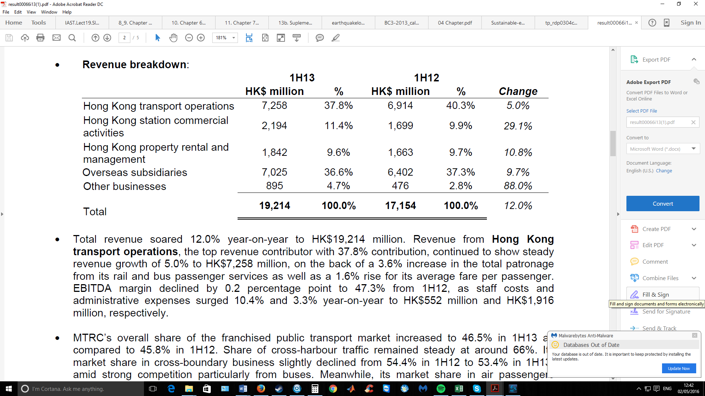

Revenue from **Hong Kong transport operations,** as MTR’s main business the report analysed a show steadygrowth from 6.9 billion to a 5.0% increase to HK$7.3 billion. Although staff costs and administration expenses increased from 10.4% and 3.3% respectively the EBITDA margin is still very high at 47.3%.

**Station commercial activities,** EBITDA margin was up approximately 2% percentage year-on-year giving a ratio of 90.6%. Expressing a very solid growth of 29.1% year-on-year to HK$2.2 billion, this is reflected directly from Hong Kong’s commercial property market increase.

Revenue from **overseas subsidiaries** including railway subsidiaries namely i) MTR Stockholm AB (“MTRS”), ii) Metro Trains Melbourne Pty. Ltd (“MTM”) and iii) MTR Corporation (Shenzhen) Limited (“SZMTR”), as well as property rental and management businesses in China, grew 9.7% year-on-year to HK$7,025 million. The increase in revenue was mainly attributable to the satisfactory operational performance in MTRS and MTM. EBITDA margin improved from 4.7% in 2nd quarter to 5.9% in 2nd quarter 13.

However, MTR’s overseas joint projects did not do as well namely i) Beijing MTR Corporation Limited (“BJMTR”), ii) London Overground Rail Operations Limited (“LOROL”), iii) Tunnel banan Teknik Stockholm AB and iv) Hangzhou MTR Corporation Limited (“HZMTR”), where a post-tax loss of HK$51 million in the 2nd quarter 13 (versus HK$204 million profit in 1H12), dragged by higher operating costs and lower passenger numbers of HZMTR which commenced operation in November 2012. It seems that MTR’s expertise rival highly with other operator as depicted by its overseas subsidiaries vs the joint overseas projects, although relatively new in partnership it may also be a joint learning curve that both MTR and its associates need to push the effectiveness of the cooperation.

**Revenue from property rental and management businesses**

The report further investigated that an increase of 10.8% year-on-year to HK$1.8 billion, from its shopping mall portfolio attained an average of 15% increase in rental reversion during this period. As of 30th June 2013, the occupancy rate of its 13 shopping malls in Hong Kong and the Group’s 18 floors at Two International Finance Centre was close to 100%.

**Profit from property development**

Profits in the 2 quarterwas valued at HK$531 million, which reports a decrease of 15.3% year-on-year, but still a substantial amount profit wise (East Asia Securities Company Limited, 2013). In June of 2013, total outstanding borrowings amounted to HK$23,231 million, decreased from HK$23,577 million as at 31st December 2012. However, as cash balance fell 8.6% half-on-half to HK$17,060 million, net debt to equity ratio slightly increased from 11.0% by end of 2012 to 11.6%. Although this account is in decrease it is well noted that this is MTR’s side business and not the main business, this additional revenue adds value to the business. So it is evident that there is a clear decrease of deficit from its initial borrowing for such development project and still making some-what of a profit, as reflected in its reported earnings per share of HK$1.06 for 1H13, up 6.0% year-on-year. Yet, interim dividend stayed unchanged at HK$0.25 per share, representing pay-out ratio of 23.6%.

**Outlook & Prospect**

***Muted property development profit in 2H13***. MTRC expects no new project completion in the second half of the year and profit booking will only come from the sale of its inventory units.

Nevertheless, the Group plans the launches of LOHAS Park (phase 3) in Tseung Kwan O and The Austin Station (site C) projects in 2H13, profits of which are expected to be recognized in 2014 to 2015. Subject to market condition, MTRC will put three sites to tender in 2H13, including i) Tai Wai Station, ii) Tin Shui Wai Light Rail and iii) LOHAS Park (phase 4) sites.

*Construction of new rail lines in Hong Kong on track*, with the completion dates drawing near year on year, from 2015 to 2020; this will not only increase revenue in MTR’s main line of business but also in development profits and station commercial rentals. The West Island Line, which was targeted to be opened in 2014, was 74% complete. Another 3 lines including the South Island Line (East), the Kwun Tong Line Extension and the Express Rail Link, which are scheduled for completion in 2015, were 41%, 44% and 41% complete, respectively. For the Shatin to Central Link, the first phase is scheduled for completion in 2018 and the second phase in 2020. EBITDA margin of the domestic transport operation segment may be under pressure in 2014 and 2015, mainly due to the large injection of investment on the high start-up costs on the commencement of the new rail lines; once this period has passed it will be sure to regain the revenue back from such large investments.

***To boost investment in China railway business***. As guided by the Management, the Group will increase its target investment in China from 10% of its total net asset value to 15%, focusing on both railway operations and the atop-railway property projects. MTRC’s upcoming projects include i) the pre-sale of the development project in Shenzhen Metro Longhua Line Depot Site Phase 1 by the end of 2014; ii) development of Beiyunhe Station project on Tianjin Metro Line 6 for commercial and residential purpose; as well as iii) the commencement of the phase 2 and 3 of Beijing Metro Line 14 in 2014 and 2016 respectively.

***Longer-than-expected time to breakeven for Hangzhou line***. HZMTR registered an attributable net loss of HK$161 million in 1H13. The Management expects HZMTR will take longer than 3 years to breakeven, due to low patronage.

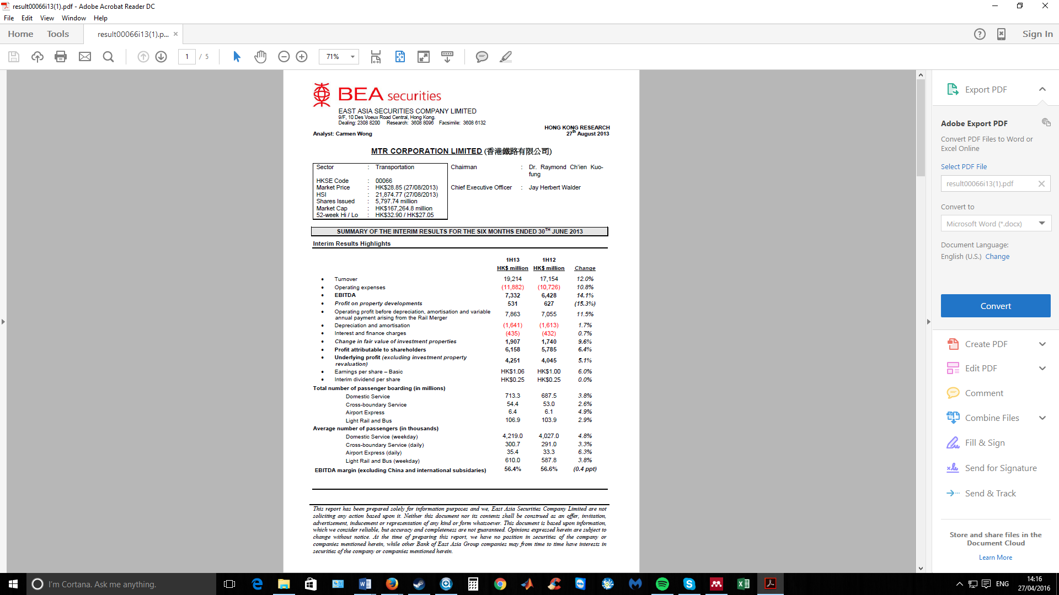

The report concludes its near-term growth as low due to its engagement of multiple expansion projects that are in-progress, many that are delayed and, noting the increase of expenses due to badly forecast expenditure. For the short term investment major risk include “weaker-than-expected patronage, a larger than expected drop in property prices and delays in launching new rail lines and property projects.” Therefore, it is not a viable invest for short-term, however from the growth momentum it is building not only from the expansion project in Hong Kong but that of International projects such as development project in Shenzhen Metro Longhua Line, Beiyunhe Station project on Tianjin Metro Line 6, and Beijing Metro Line 14 the growth potential is strong for medium to long-term.